
Week 1

MENU

LUNCH

LUNCH
Fishfingers with wedges
and peas
(gluten)

Homemade banana oat bars

SNACK
Homemade mini fruit scones (under 12 months will have no raisins)
(gluten, egg)

TEA
Crumpets with jam,
marmite, spread
(Gluten, egg)

Greek yoghurt and fruit puree
(dairy)

Greek yoghurt and fruit puree
(Dairy)

LUNCH
Jacket potatoes with cheese and baked beans
(Dairy)

Fresh fruit

SNACK
Rice cakes

TEA
Couscous served with peas, sweetcorn and diced carrots
(Dairy, semolina, gluten)

Homemade cherry and oat bars

LUNCH
Beef and vegetable lasagne served with garlic bread
(Dairy, gluten)

Summer fruit yoghurt
(dairy)

SNACK
Honeydew/watermelon

TEA
Cheese croissants served with salad
(Dairy, egg)

Homemade butterfly cakes
(Dairy, Egg)

LUNCH
Homemade pizza served with diced potatoes and
baked beans
(Dairy, gluten)

Jelly
(gelatine)

SNACK
Cream cheese and crackers
(gluten, milk)

TEA
Selection of sandwiches
(Dairy, gluten)

Fresh fruit

LUNCH
Roast chicken, roast potatoes and baby carrots

Fresh fruit

SNACK
Buttered fruit loaf
(gluten, egg, milk)

TEA
Wholemeal rolls served with cheese spread, chicken
and salad
(Dairy)

Apricot & chocolate chip
chewy bars
(Dairy)

Friday
Thursday
Wednesday
Monday
Tuesday

Week 2

MENU

LUNCH
Gammon ham served with mashed potatoes and beans
(gluten)

Homemade orange muffins
(egg, gluten)

SNACK
Biscuit
(gluten)

TEA
Cheesy pasta served with cucumber sticks
(Dairy, Gluten)

Fruit yoghurt

Choc Ice
(Dairy )

LUNCH
Fish fingers, diced potatoes and peas

Jelly
(gelatine)

SNACK
Watermelon/honeydew melon

TEA
Houmous wraps
with salad
(gluten, sesame)

Homemade blueberry scrolls
(dairy, gluten)

LUNCH
Sausages served new potatoes, baby carrots and gravy
(soya, gluten)

Greek yoghurt with fruit puree
(Dairy)

SNACK

Cucumber sticks with cheese spread
(milk)

TEA
Chicken or cheese sandwiches made with wholemeal bread and salad
(Gluten)

Homemade fairy cakes
(Dairy, egg)

Blueberry Muffins
(Dairy, Egg, Gluten)

LUNCH
Homemade vegetable layer bake served with broccoli
(Dairy, Gluten)

Homemade strawberry crumble bars
(Gluten)

SNACK
Homemade mini blueberry scones
(gluten, milk)

TEA
Pizza slices served with salad sticks
(Dairy, Gluten)

Fresh Fruit

LUNCH
Butter chicken curry served with rice
(Gluten, Dairy)

Fresh fruit

SNACK
Rice cakes

TEA
Ham ploughmans with wholemeal bread
(gluten)

Yoghurt
(Dairy)

Friday
Thursday
Wednesday
Tuesday
Monday

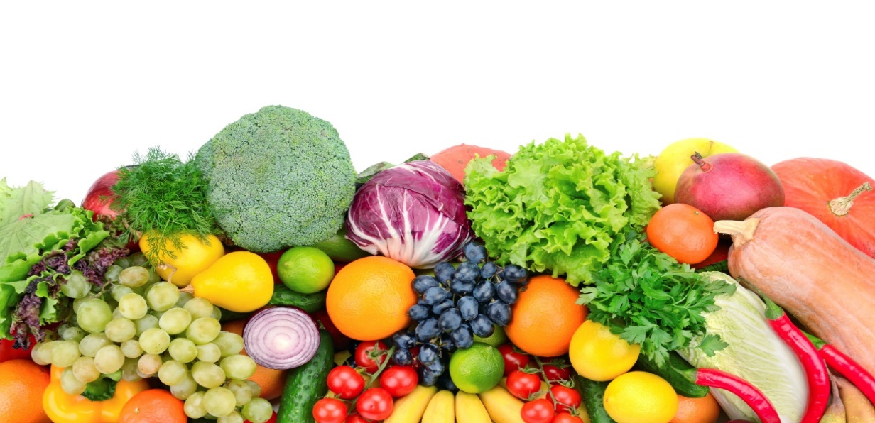
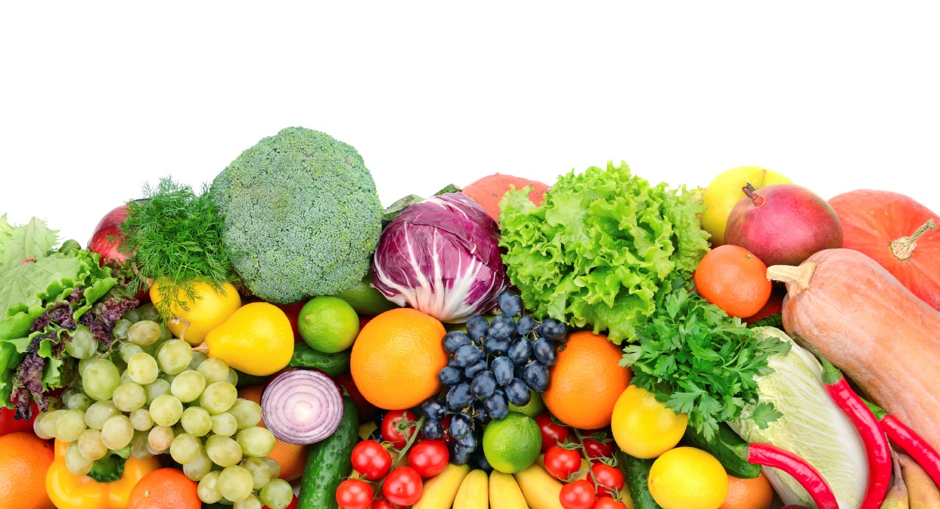
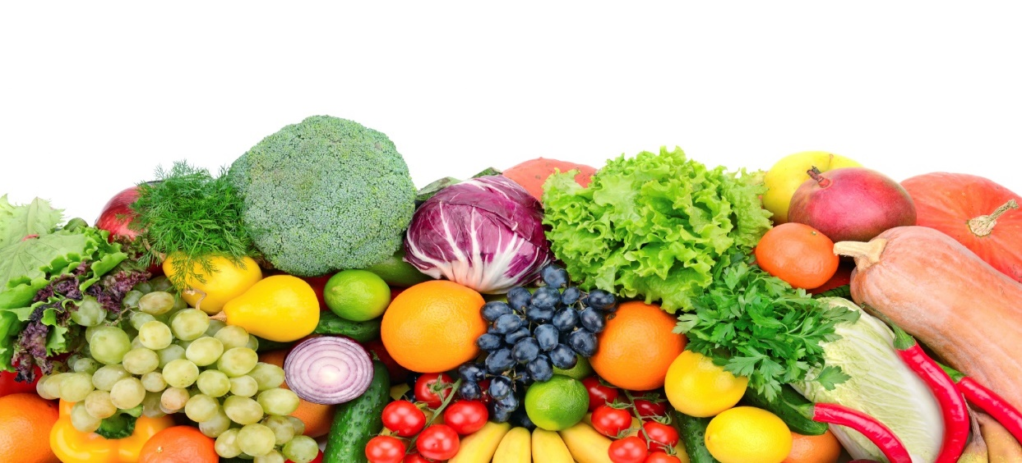

BREAKFAST
A choice of cereals & Toast
(Gluten, Milk)

LUNCH
Homemade Macaroni Cheese served with Broccoli
Apple & Cinnamon Crumble & Custard

TEA
A Selection of Wraps served with Salad Sticks
Fruit Yoghurt

BREAKFAST
A choice of cereals & Toast
(Gluten, Milk)

LUNCH
Roast Chicken served with Roast Potatoes, Carrots, Stuffing & Gravy
Mixed Berry Muffin

TEA
Spaghetti Hoops on Wholemeal Toast
Fresh Fruit Slices

BREAKFAST
A choice of cereals & Toast
(Gluten, Milk)

LUNCH
Homemade Chicken & Autumn Vegetable Stew served with Mashed Potatoes
Mixed Berry Muffins

TEA
Cheesy Jacket Potato served with Cherry Tomatoes & Cucumber Sticks
Chocolate Oat Cake with Banana Slices

BREAKFAST
A choice of cereals & Toast
(Gluten, Milk)

LUNCH
Jacket Potato served with Cheddar Cheese & Baked Beans
Chocolate Mousse

TEA
Ploughman’s Platter served with Cucumber Sticks
Bananas & Custard

Thur
Week 3

MENU
Friday
Thursday
Wednesday
Tuesday
Monday

LUNCH
Cottage pie with mixed veg
(gluten)

Homemade shortbread
(gluten)

SNACK
Homemade mini cheese scones
(gluten, milk)

TEA
Wholemeal Warburton thins served with a selection of fillings
(Gluten)

Fresh fruit

LUNCH
Roast chicken, roast potatoes, peas and gravy
(Soya, Gluten)

Fresh fruit

SNACK
Biscuit
(gluten)

TEA
Tuna pasta mayo
(egg, gluten)

Jelly
(gelatine)

LUNCH
Homemade sausage pie with mashed potatoes and baby carrots
(Soya, gluten)

Fruit puree and Greek yoghurt
(Dairy)

SNACK
Watermelon/honeydew melon

TEA
Cheese and crackers served with grapes
(Gluten, Dairy, egg)

Freshly baked cookies
(Dairy, Egg)

LUNCH
Homemade tomato and mozzarella orzo served with garlic bread
(Gluten, Dairy, egg)

Homemade gingerbread
(gluten, egg)

SNACK
Buttered fruit loaf (under 12 months will have alternative)
(gluten, soya, milk)

TEA
Savoury scones served with tomato pieces
(gluten, dairy)

Fresh fruit
(dairy)

LUNCH
Ratatouille served with pasta
(gluten)

Yoghurt
(dairy)

SNACK
Crackers and cheese spread
(gluten, milk)

TEA
Hot dogs
with salad
(gluten)

Homemade jam tarts
(gluten)

