Week 1

MENU

LUNCH
Mediterranean pasta served with cheese
(Dairy, Gluten)

Freshly baked biscuit
(Dairy, Gluten)

TEA
Burger in a bun with salad
(Gluten)

Fruit yogurt
(Dairy)

LUNCH
Chicken goujons served with diced potatoes and peas
(Gluten)

Fruit yogurt
(Dairy)

TEA
Assorted filled sandwiches served with cucumber and crisps
(Gluten, Dairy, Soya)

Homemade shortbread
(Gluten, Dairy)

LUNCH
Toad in the hole, served with potatoes and mixed vegetables
(Dairy, Egg, Gluten, Soya)

Homemade apple cake
(Dairy, Egg, Gluten)

TEA
Cheese croissant with vegetable sticks
(Gluten, Dairy, Egg)

Fresh fruit

LUNCH
Butter chicken curry served with Bombay potatoes
(Dairy)

Fresh fruit

TEA
Homemade ham and vegetable muffins served with salad
(Gluten, Dairy, Soya)

Chocolate mousse
(Dairy, Gelatine)

LUNCH
Beef cobbler served with potatoes and green beans
(Gluten, Dairy, Soya)
Chocolate oaties
(Dairy, Gluten)

TEA
Cheese served on crackers with grapes
(Dairy, Gluten, Egg)

Sliced melon and pineapple

Friday
Thursday
Wednesday
Monday
Tuesday

Week 2

MENU

LUNCH
Fish fingers served with cheesy mashed potatoes and baked beans
(Dairy, Fish, Gluten)

Selection of Fresh Fruit

TEA
Pizza served with slices of pepper
(Dairy, Gluten)

Fairy cake
(Dairy, Egg, Gluten)

LUNCH
Sausage pie served with potatoes, peas and gravy
(Gluten, Dairy, Soya)

Flapjack
(Dairy, Gluten)

TEA
Ploughmans
(Gluten, Dairy, Egg)

Chocolate chip cookie
(Dairy, Egg, Gluten)

LUNCH
Jacket potatoes filled with beef chilli and grated cheese
(Dairy, Soya, Gluten)

Chocolate mousse
(Dairy, Gelatine)

TEA
Assorted filled sandwiches served with crisps and salad
(Dairy, Gluten, Soya)

Fresh fruit

LUNCH
Chicken in a mushroom sauce, served with new potatoes and baby carrots
(Soya, Gluten)

Homemade traybake
(Dairy, Gluten, Egg)

TEA
Chicken or cheese filled wholemeal Warburton thins served with salad and crisps
(Dairy, Gluten, Soya)

Banana custard
(Dairy)

LUNCH
Vegetable pasta bake served with garlic bread
(Gluten, Dairy)

Fruit yogurt
(Dairy)

TEA
Tomato soup served with bread and butter
(Dairy, Gluten, Soya)

Home made cake
(Dairy, Egg, Gluten)

Friday
Thursday
Wednesday
Tuesday
Monday

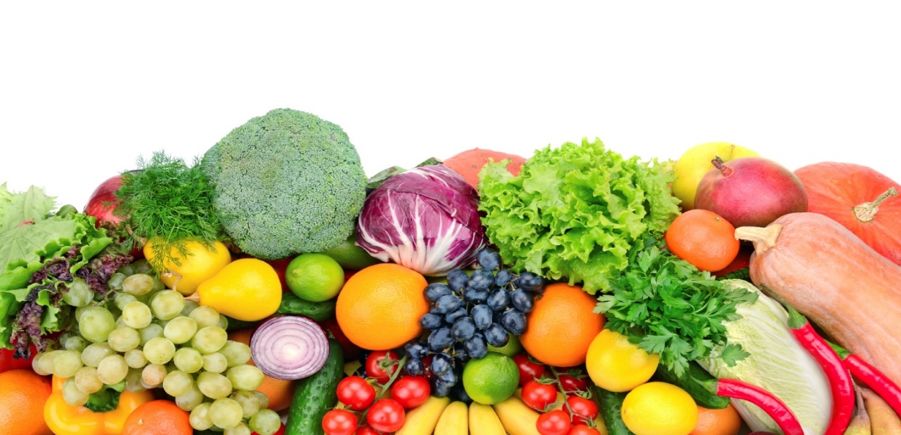
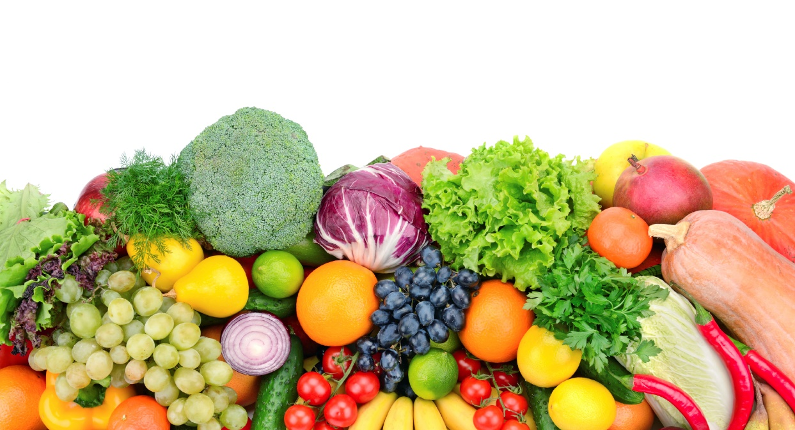
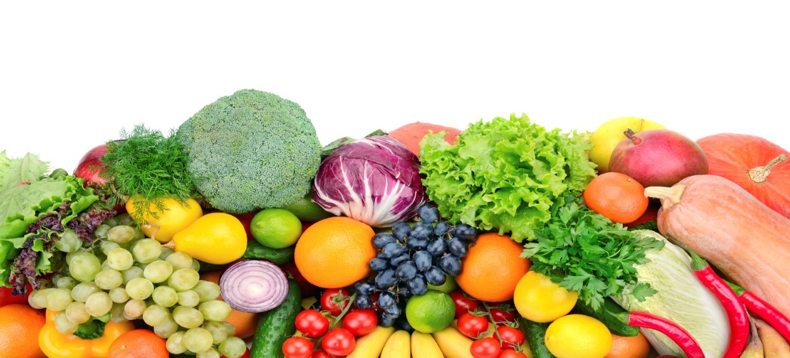

BREAKFAST
A choice of cereals & Toast
(Gluten, Milk)

LUNCH
Homemade Macaroni Cheese served with Broccoli
Apple & Cinnamon Crumble & Custard

TEA
A Selection of Wraps served with Salad Sticks
Fruit Yoghurt

BREAKFAST
A choice of cereals & Toast
(Gluten, Milk)

LUNCH
Roast Chicken served with Roast Potatoes, Carrots, Stuffing & Gravy
Mixed Berry Muffin

TEA
Spaghetti Hoops on Wholemeal Toast
Fresh Fruit Slices

BREAKFAST
A choice of cereals & Toast
(Gluten, Milk)

LUNCH
Homemade Chicken & Autumn Vegetable Stew served with Mashed Potatoes
Mixed Berry Muffins

TEA
Cheesy Jacket Potato served with Cherry Tomatoes & Cucumber Sticks
Chocolate Oat Cake with Banana Slices

BREAKFAST
A choice of cereals & Toast
(Gluten, Milk)

LUNCH
Jacket Potato served with Cheddar Cheese & Baked Beans
Chocolate Mousse

TEA
Ploughman’s Platter served with Cucumber Sticks
Bananas & Custard

Thur
Week 3

MENU
Friday
Thursday
Wednesday
Tuesday
Monday

LUNCH
Gammon ham served with mashed potatoes and peas
(Dairy)

Freshly baked cake
(Dairy, Egg, Gluten)

TEA
Spaghetti hoops on toast
(Gluten, Dairy, Soya)

Fruit Yoghurt
(Dairy)

LUNCH
Sausages served with mashed potatoes, mixed vegetables and gravy
(Soya, Gluten)

Fresh Fruit

TEA
Selection of crackers, served with cheese and grapes
(Gluten, Dairy, Egg)

Chocolate crispy cake
(Dairy, Gluten)

LUNCH
Jacket potatoes filled with cheese and baked beans
(Dairy)

Chocolate mousse
(Dairy, Gelatine)

TEA
Assorted filled wholemeal Warburton thins, served with crisps and salad
(Gluten, Dairy, Soya)

Flapjack
(Dairy, Gluten)

LUNCH
Meatballs in a tomato sauce, served with pasta
(Gluten)

Fruit yogurt
(Dairy)

TEA
Crumpets topped with jam or lemon curd
(Dairy, Egg, Gluten)

A selection of fresh Fruit

LUNCH
Fish bites served with croquette potatoes and sweetcorn
(Dairy, Fish, Gluten)

Banana Custard
(Dairy)

TEA
Tuna or cheese sandwiches served with crisps and salad
(Fish, Gluten, Dairy, Soya)

Jelly

Snack MENU
 | Monday | Tuesday | Wednesday | Thursday | Friday
Week 1  am  pm | Fruit  Savoury crackers  (Gluten, Egg, Dairy) | Fruit  Fruit loaf  (Gluten, Dairy, Soya) | Fruit  Biscuit  (Gluten) | Fruit  Rice cake | Fruit  Breadsticks and dips  (Gluten, Dairy)
Week 2  am  pm | Fruit  Biscuit  (Gluten) | Fruit  Savoury crackers  (Gluten, Egg, Dairy) | Fruit  Breadsticks and dips  (Gluten, Dairy) | Fruit  Cheese scone  (Gluten, Dairy) | Fruit  Rice Cake
Week 3  Am  pm | Fruit  Vegetable sticks and cheese dips  (Dairy) | Fruit  Cheese straws  (Gluten, Dairy) | Fruit  Rice Cake | Fruit  Biscuit  (Gluten) | Fruit  Fruit Loaf  (Gluten, Dairy, Soya
All snacks are served with milk or water. All food is subject to availability and may be subject to change.

